**Basics of Mathematical Software**

Nguyen Quoc Huy - e1601121

I-IT-2N

### Project Work Propositions

We select 2 points on the map figure and then matlab finds out the shortest path between them. This project can be used in find the shortest way in some map application.

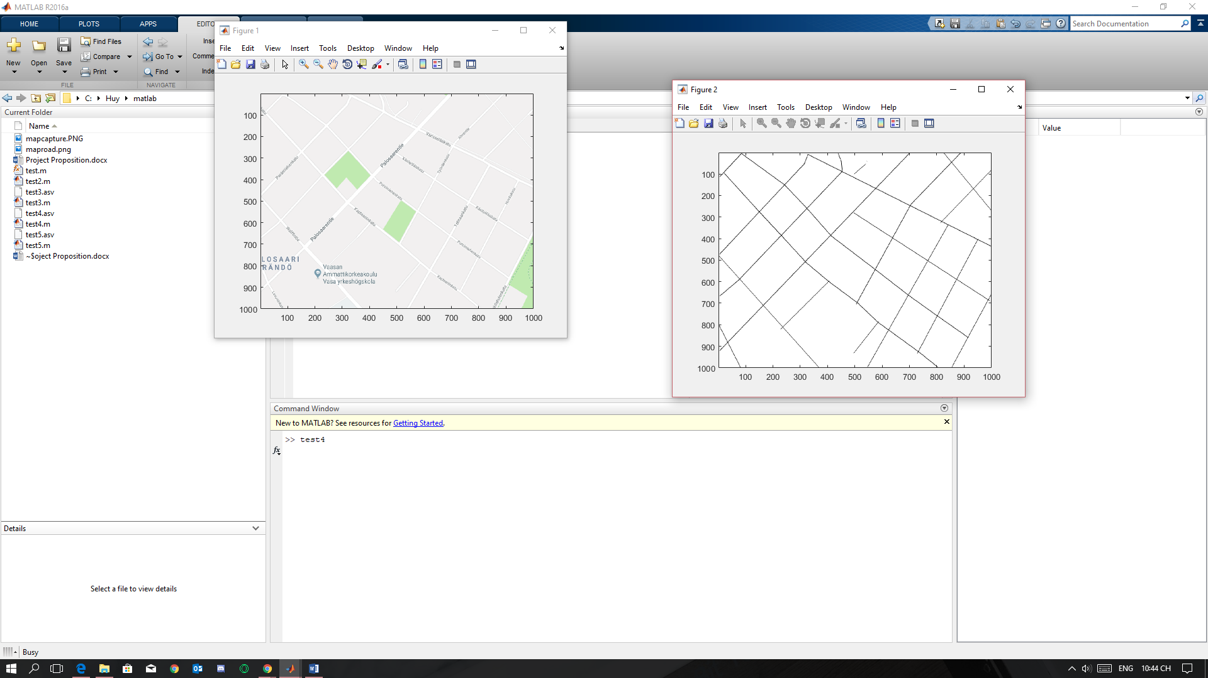

The idea of the algorithm is based on the function *shortestpath* in matlab, which can find out shortest path between 2 nodes. So basically, the project will handle the data by declare nodes for all the special points of the map.

